**GRADE XI UNITS AND MEASUREMENT**

**Physical quantity**-A physical quantity is something that can be measured.

Eg. mass , length.

Measurement of any physical quantity involves comparison with a certain basic, arbitrarily chosen, internationally accepted reference standard called unit. The result of a measurement of a physical quantity is expressed by a number (or numerical measure) accompanied by a unit. The units for the fundamental or base quantities are called fundamental or base units. The units of all other physical quantities can be expressed as combinations of the base units. Such units obtained for the derived quantities are called derived units. A complete set of these units, both the base units and derived units, is known as the system of units. In earlier time scientists of different countries were using different systems of units for measurement. Three such systems, the CGS, the FPS (or British) system and the MKS system were in use extensively till recently. The base units for length, mass and time in these systems were as follows :

• In CGS system they were centimetre, gram and second respectively.

• In FPS system they were foot, pound and second respectively.

• In MKS system they were metre, kilogram and second respectively. The system of units which is at present internationally accepted for measurement is the Système Internationale d’ Unites (French for International System of Units), abbreviated as SI. In SI, there are seven base units as given in table 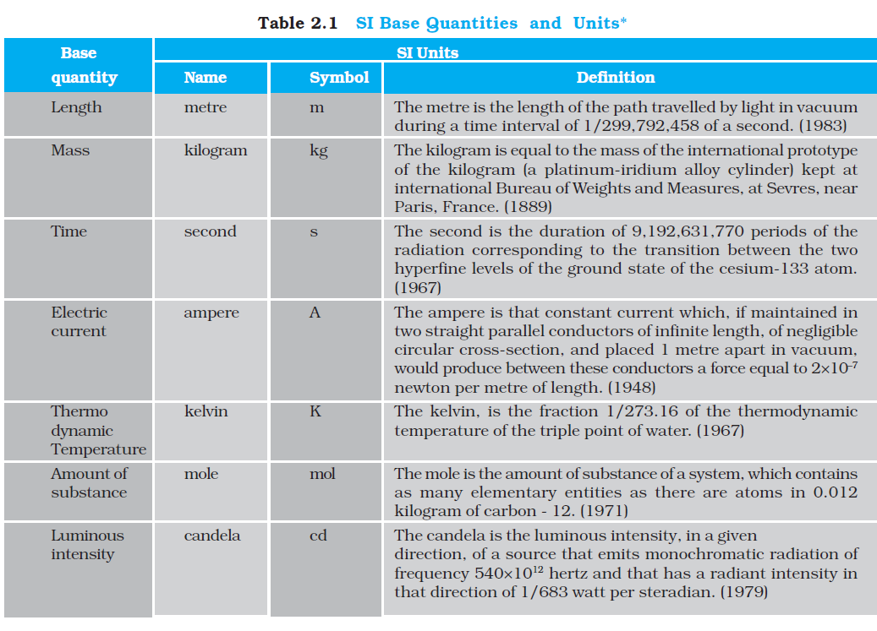

Besides the seven base units, there are two more units that are defined for (a) plane angle dθ as the ratio of length of arc ds to the radius r and (b) solid angle dΩ as the ratio of the intercepted area dA of the spherical surface, described about the apex O as the centre, to the square of its radius r, as shown in Fig.



The unit for plane angle is radian with the symbol rad and the unit for the solid angle is steradian with the symbol sr. Both these are dimensionless quantities.

**Characteristics of a standard unit**

1.It should be well defined.

2.It should be of suitable size.

3.It should be easily reproducible.

4.It should not change from time to time and from place to place.

5. It should not change with physical conditions such as pressure and temperature.

6. It should be easily accessible.

**Advantages of SI unit**

1. It is a coherent system of unit-all derived units can be obtained by multiplying or dividing a certain sets of basic units
2. It is a rational system of unit.-it uses only one unit for a physical quantity.
3. This system of unit is a metric system : all multiples and submultiples can be expressed as powers of 10.
4. This system is closely related to cgs system.
5. It is internationally accepted.

**Other practical units of length**

Light year- It is the distance travelled by light in one year.

1 light year=9.46 x 1015m.

**Astronomical unit(AU)**

It is the mean distance of the sun from earth.

1AU = 1.5x 10 11m

**Dimensions** of a physical quantity are the powers to which the fundamental quantities such as mass , length and time are to be raised to obtain the given physical quantity.

|  |  |  |
| --- | --- | --- |
| physical quantity | Dimensions | S.I unit |
| Area |  |  |
| Volume |  |  |
| Density=mass/volume |  |  |
| Frequency f= 1/T |  |  |
| Distance/Displacement |  |  |
| Speed/ velocity |  |  |
| Force=ma |  |  |
| Work=f.s(Energy) |  |  |
| Momentum(p)=mv |  |  |
| POWER P |  |  |

**The principle of homogeneity of dimensions: It states that an equation is correct only if the dimensions of each term are the same.**