EXPERIMENT 14
P.N.DIODE
Day & Date:
Aim: To Draw the I-V characteristics of a P.N. Diode in forward bias and hence to determine static and dynamic resistance of the diode.
Theory:
Static resistance = Direct voltage required / Direct current required at that stage.
Dynamic resistance = Peak to peak alternating voltage / Peak to peak alternating current
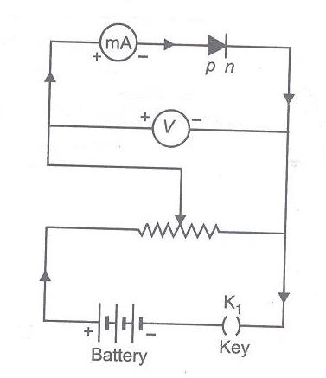
OBSERVATIONS: CIRCUIT DIAGRAM:
No. | Voltmeter reading | Ammeter reading

RESULT:
- Static resistance of the diode =
- Dynamic resistance of the diode =

